MOBILE APPLICATION DEVELOPMENT LOGBOOK
Name: Lenah Moraa Akama
Reg No: BIT/2024/54491
Course: Mobile Application Development
Project Title: Student Management Mobile App
Institution: Mount Kenya University

WEEK 1
Objectives:
1.Install all developed tools
2.Create one flutter app
3.Changing app title, background color, font size
4.Submit screenshots

Activities Done:
- Installed Visual Studio,
- Create first, Flutter project using flutter SDK and Java SDK
- Configured Visual Emulator
- Verified setup using flutter doctor
- Ran application on emulator and modified UI (title, colors, font size)

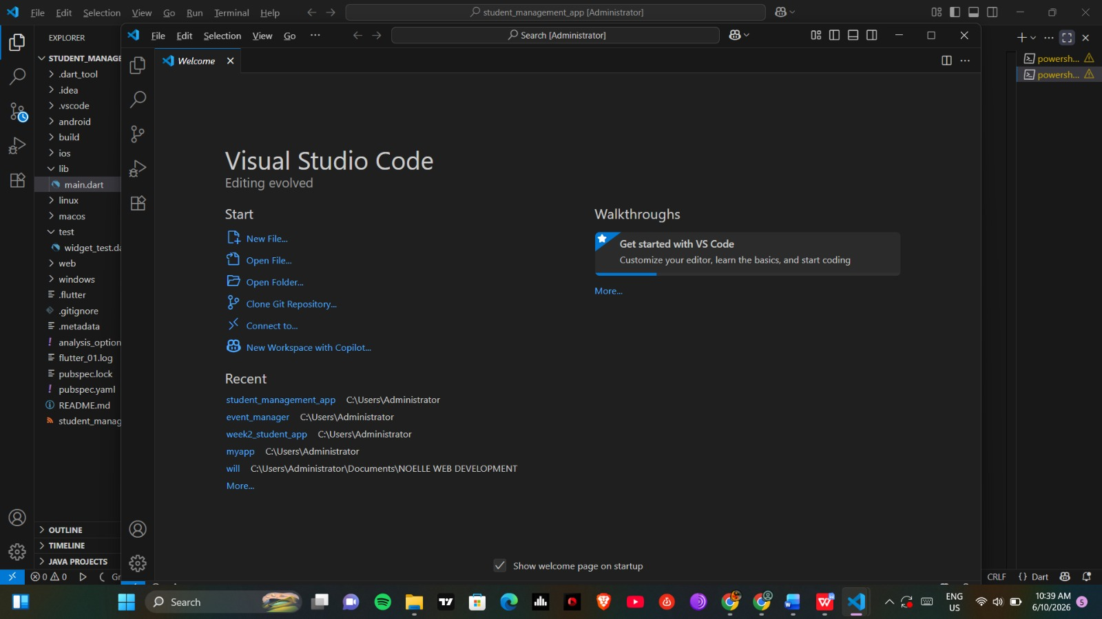

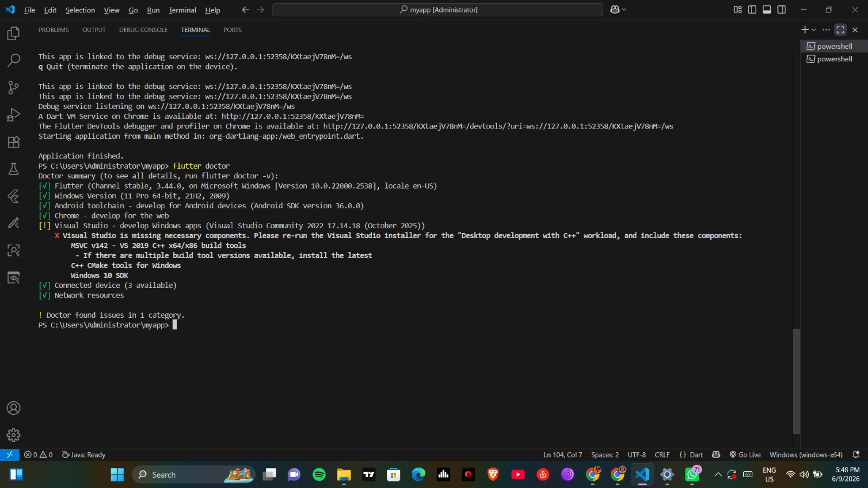

Challenges faced: Emulator was not launching
Solution implemented: Created a new virtual device and verified virtualization settings

WEEK 2: UI DEVELOPMENT
Objectives
1.Build a mini student management app with the following features:
Login page
Student registration
Saves records locally
Simple navigation

Activities done:
- Learned basic Dart widgets (Text, Column, Row, Container)
- Designed Login and Registration screens
- Implemented basic navigation between screens
Started student form UI
Evidence: Insert screenshots of login and registration screens.

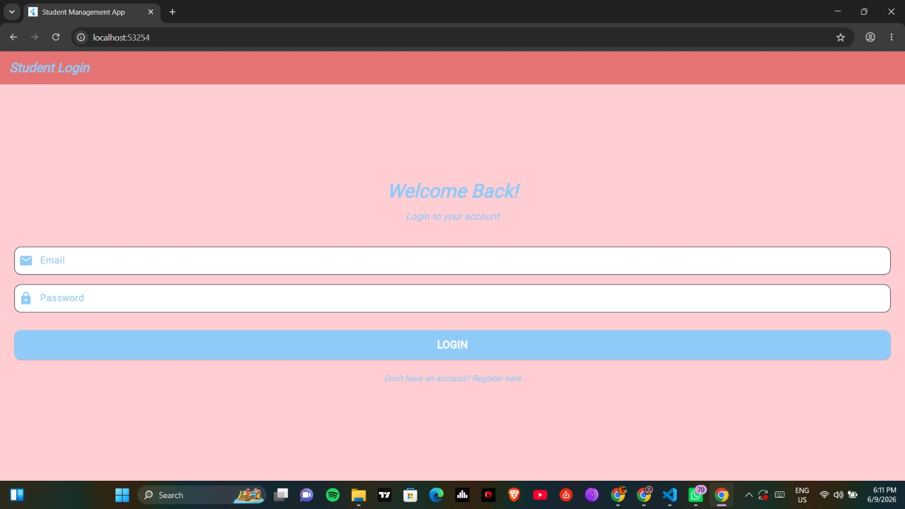
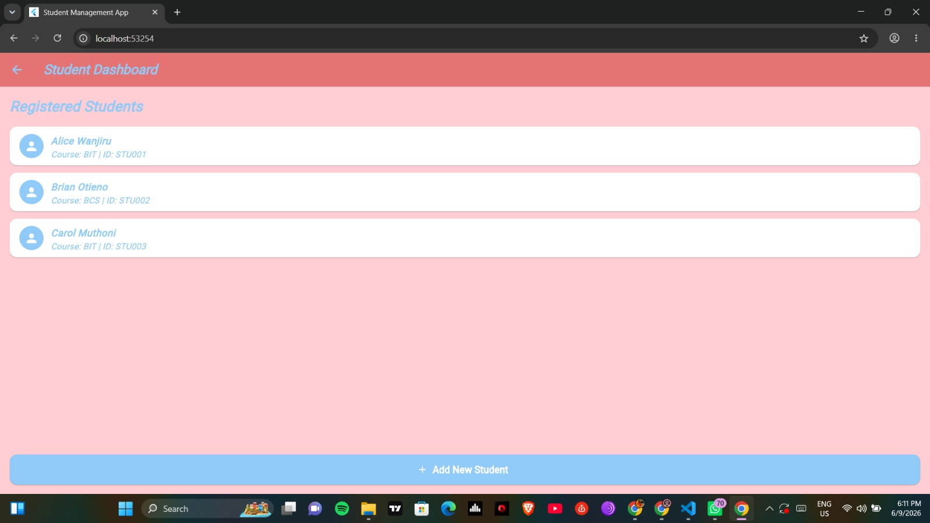

Challenges: application crashed when navigating between screens
Solution Implemented: Checked route definitions and fixed null value errors

WEEK 3: APP DEVELOPMENT & TESTING
Objectives
1.Navigation working
2.Responsive design
3.Modern UI
4.Functional forms
Activities Done:
- Implemented navigation using Navigator.push
- Tested application on Android emulator
Evidence: Insert screenshots of full app and navigation flow.

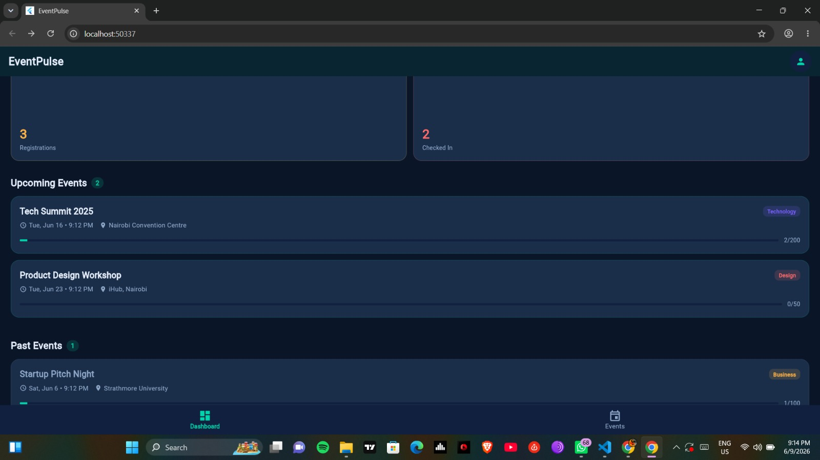

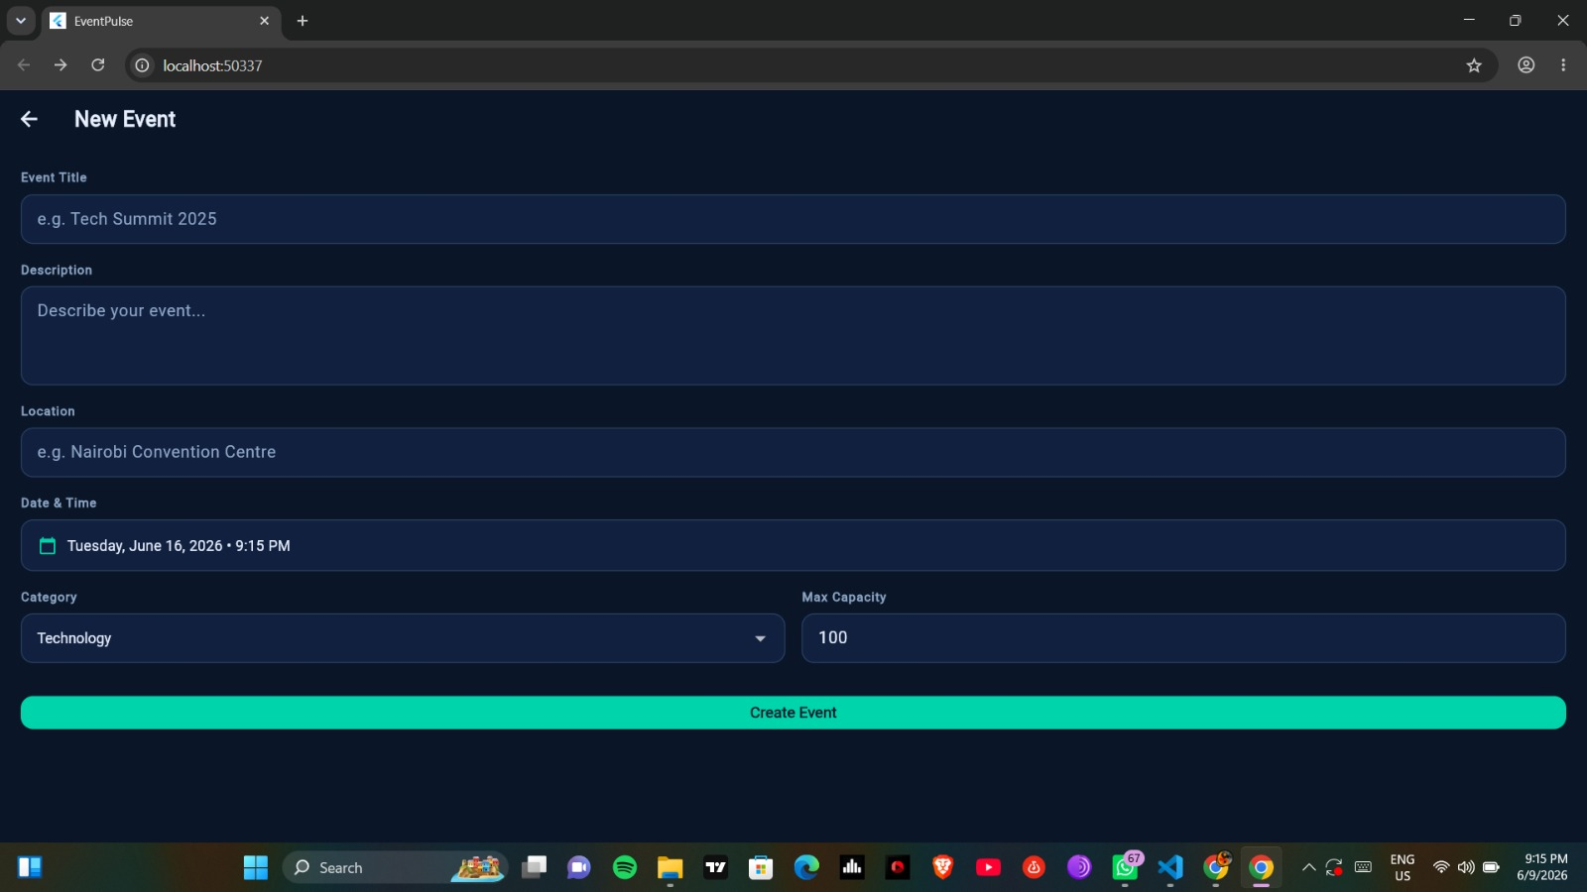

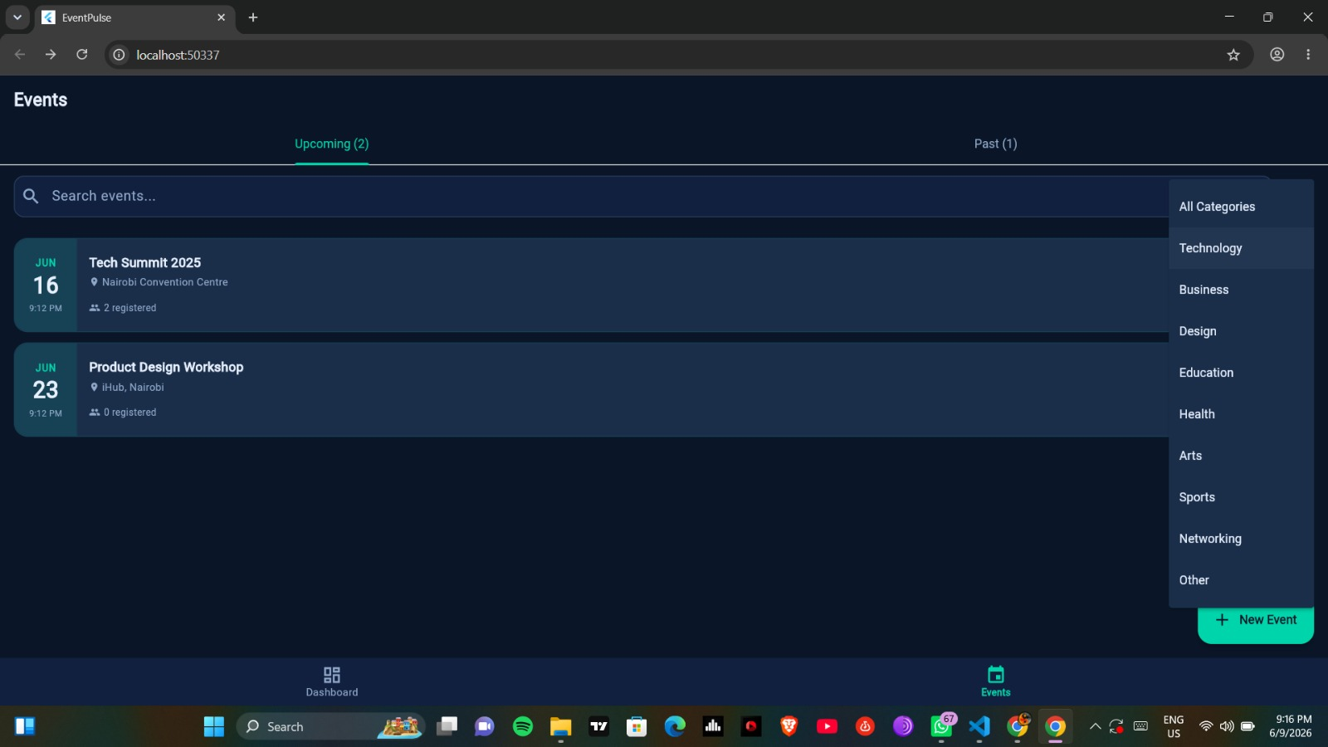

Challenges: Emulator was slow and took a long time to start .
Solutions implemented: increased RAM allocation and closed unnecessary application

TOOLS USED
- visual Studio
- Flutter SDK
- Dart
- VS Code
- Git & GitHub

Reflection
During this phase, I learnt how to implement screen navigation, save and retrieve data from databases and test mobile applications using an android emulator.

Supervisor Signature

